# PCB

# Introduction

The purpose of this document is to describe the PCB Block of the Wearable Sensor for the Blind ECE Senior Capstone Project to other engineers with enough detail such that they would be able to reproduce this block using only this document as reference. Included in this document are an overview of the block, a schematic and layout diagram, and a complete bill of materials for the PCB.

# Block Overview

The PCB block links together all the individual components of the system. It provides the necessary connectors to wire together the system processing blocks to the sensor blocks and haptic feedback block. It will also hold the 3.3V regulator, which will power every component in the system. Fig. 1 below shows all the connectors needed on the PCB. This block was completed by Sean Sylwester.

Microcontroller Pinout

Bluetooth Pinout

Ultrasonic Sensor Pinout

Laser ToF Sensor Pinout

Magnetometer Pinout

Battery Pinout

3.3V Regulator

# Fig. 1. Block Diagram of the PCB Block

## Schematic

Fig. 2 below shows the schematic of the PCB corresponding to the block diagram shown in Fig. 1.

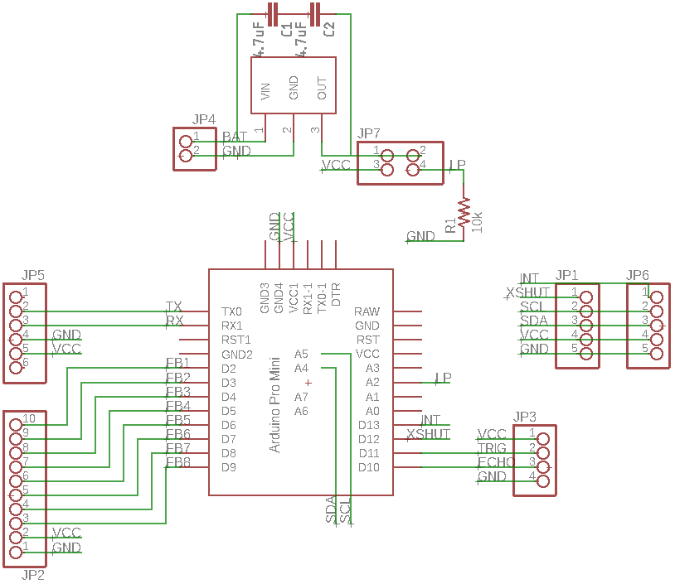

Fig. 2. PCB Schematic



## PCB Artwork

Fig. 3 and Fig. 4 below show the physical layout of the PCB according to the schematic shown in Fig. 2.

[Link to Gerber Files](https://drive.google.com/open?id=1scWGoh0TF6BvrzUmga4uNgtTrX0DzVw1)

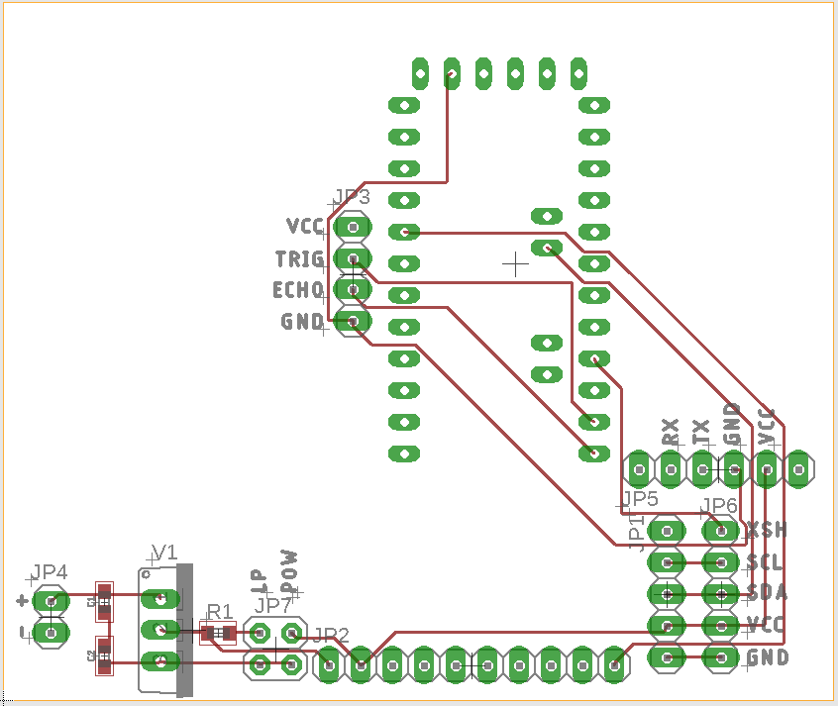

Fig. 3. PCB Layout Top

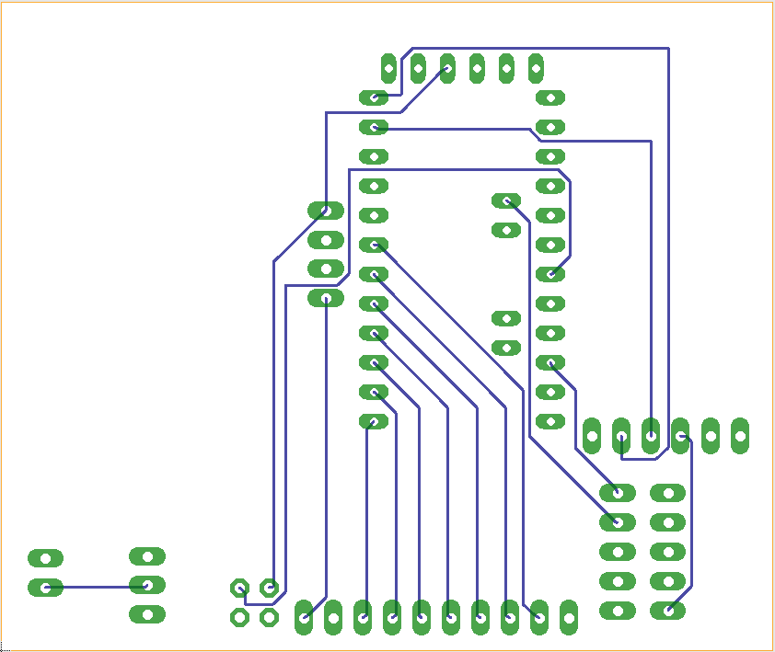

Fig. 4. PCB Layout Bottom

## 

## Bill of Materials

Table I. Bill Of Materials For The PCB Block

| Reference Designator | Description | Manufacturer | Manufacturer Part Number | Suppliers | Package | Quantity | Unit Price |
| --- | --- | --- | --- | --- | --- | --- | --- |
| C1 C2 | Multilayer Ceramic Capacitors MLCC - SMD/SMT 4.7uF 10V X5R +/-10% 0603 Gen Purp | Taiyo Yuden | LMK107BJ475KA-T | Mouser | 0603 in 1608 mm | 2 | $0.22 |
| R1 | RES SMD 10K OHM 1% 1/8W 0603 | Vishay Beyschlag | MCT06030C1002FP500 | Digi-Key | 0603 in  1608 mm | 1 | $0.18 |
| JP1, JP6 | 1x5 Female Header | Sullins Connector Solutions | PPTC051LFBN-RC | Digi-Key | 1x5 | 2 | $0.47 |
| JP2 | 1x10 Female Header | Sullins Connector Solutions | PPTC101LFBN-RC | Digi-Key | 1x10 | 1 | $0.65 |
| JP3 | 1x4 Female Header | Sullins Connector Solutions | PPTC041LFBN-RC | Digi-Key | 1x4 | 1 | $0.45 |
| JP4 | 1x2 Female Header | Sullins Connector Solutions | PPTC021LFBN-RC | Digi-Key | 1x2 | 1 | $0.32 |
| JP5 | 1x6 Female Header | Sullins Connector Solutions | PPTC061LFBN-RC | Digi-Key | 1x6 | 1 | $0.52 |
| JP7 | 2x2 Female Header | Sullins Connector Solutions | PPTC022LFBN-RC | Digi-Key | 2x2 | 1 | $0.57 |
| U1 | Arduino Pro Mini | Arudino | Pro Mini 3.3V | Digi-Key | Pro Mini | 1 | $14.99 |
| U2 | LDO Voltage Regulators Low Power 3 Ampere | Texas Instruments | UCC283T-5 | Mouser | TO220 | 1 | $7.88 |

## Approval Log

Table 2 below records the approval signatures for the PCB’s schematic, layout and bill of materials.

Table 2. PCB Approval Log

| Schematic Approved | Signature: Sean Sylwester | Date: 3/12/18 |
| --- | --- | --- |
| **PCB Approved** | Signature: Sean Sylwester | Date: 3/13/18 |
| **Bill of Materials Complete** | Signature: Sean Sylwester | Date: 3/13/18 |